DCHAS-L@princeton.edu
sigmannsb@appstate.edu
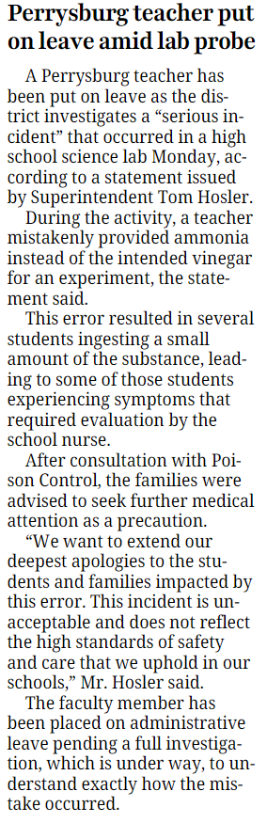
This news item appeared on page B-1 of the Saturday; 30-Nov-24 issue of The Blade (Toledo, Ohio).
The teacher use ammonia instead of vinegar in a demonstration and the students were apparently allowed to eat/taste the resulting mixture.
I will forward additional information as it is reported.

Regards,
Ernest Lippert
ernielippert@toast.net

